LAPORAN TUGAS AKHIR BASIS DATA

Untuk Memenuhi Ujian Akhir Semester Mata Basis Data dan Prak. Basis Data (Kelas G)



Oleh:

1. Muhammad Kezban Ramadzan (4523210116)
2. Reza Brema Ginting (4523210092)
3. Ernanda Dzkya (4523210115)

Dosen:

**Adi Wahyu Pribadi, S.Si., M.Kom S1-Teknik Informatika**

**Fakultas Teknik Universitas Pancasila 2024/2025**

**IDENTIFIKASI ENTITAS UTAMA, ATRIBUT, DAN RELASI ANTAR ENTITAS ENTITAS MASTER**

| **Pelanggan** | |
| --- | --- |
| ID Pelanggan | INT (Primary Key) |
| Nama | BIGINT |
| Alamat | VARCHAR |
| Nomor Handphone | VARCHAR |
| Email | VARCHAR |

| **Karyawan** | |
| --- | --- |
| ID Karyawan | INT (Primary Key) |
| Nama Karyawan | VARCHAR |
| Jabatan | VARCHAR |
| Nomor Handphone | VARCHAR |
| Gaji | DECIMAL |

| **Menu** | |
| --- | --- |
| ID Menu | INT (Primary Key) |
| Nama Menu | VARCHAR |
| Harga | DECIMAL |
| Deskripsi | TEXT |
| Kategori | ENUM (‘Makanan’,’Minuman) |

| Pesanan | |
| --- | --- |
| ID Pesanan | INT (Primary Key) |
| Tanggal Pesanan | VARCHAR |
| Total Harga | BIGINT |
| Status Pesanan | VARCHAR |
| ID Pelanggan | INT |
| ID Karyawan | INT |

| **Detail Pesanan** | |
| --- | --- |
| ID Detail | INT (Primary Key) |
| ID Pesanan | INT |
| ID Menu | INT |
| Jumlah Pesanan | INT NOT NULL |
| Subtotal | DECIMAL |

**ENTITAS RELASI**

| **Pesanan** | |
| --- | --- |
| ID Pelanggan | INT (Primary Key) |
| ID Karyawan | INT |
| ID Meja | INT |

| **Detail Pesanan** | |
| --- | --- |
| ID Pesanan | INT (Primary Key) |
| ID Menu | INT |

**RELASI**

1. Pelanggan - Pesanan

Relasi: Satu pelanggan dapat memiliki banyak pesanan.

Tipe relasi: one-to-Many.

1. Karyawan - Pesanan

Relasi: Satu karyawan dapat melayani banyak pesanan

Tipe relasi: One-to-Many.

1. Meja - Pesanan

Relasi: Satu meja dapat digunakan dalam banyak pesanan (berbeda waktu).

Tipe relasi: One-to-Many.

1. Pesanan- Detail Pesanan

Relasi: Satu pesanan dapat memiliki banyak detail pesanan.

Tipe relasi: One-to-Many.

1. Menu - Detail Pesanan

Relasi: Satu menu dapat muncul di banyak detail pesanan.

Tipe relasi: One-to-Many.

1. **BUAT ERD UNTUK MENGGAMBARKAN STRUKTUR DATABASE**

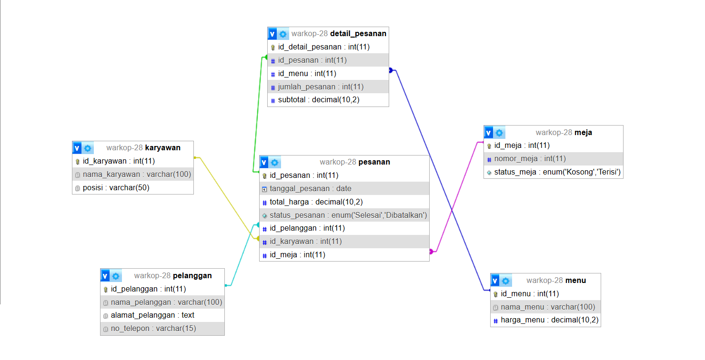

1. **BUAT STRUKTUR DATABASE MENGGUNAKAN MYSQL**

| **Keterangan** | **Perintah dan Tampilan** |
| --- | --- |
| Membuat database warkop_28 | CREATE DATABASE warkop_28 |
| Membuat tabel pelanggan | 1. CREATE TABLE pelanggan (   id_pelanggan INT AUTO_INCREMENT PRIMARY KEY,  nama VARCHAR(100) NOT NULL,  alamat VARCHAR(255),  nomor_telepon VARCHAR(20),  email VARCHAR(100)  ) ENGINE=InnoDB DEFAULT CHARSET=utf8mb4; |
|  |  |
|  |  |
|  |  |
|  |  |
|  |  |
|  |  |
|  |  |
|  |  |
|  |  |

|  |  |
| --- | --- |
| Membuat Tabel Karyawan | 1. CREATE TABLE karyawan (   id_karyawan INT AUTO_INCREMENT PRIMARY KEY,  nama_karyawan VARCHAR(100) NOT NULL,  jabatan VARCHAR(50),  nomor_telepon VARCHAR(20),  gaji DECIMAL(10, 2)  ) ENGINE=InnoDB DEFAULT CHARSET=utf8mb4; |
| Mebuat Tabel Menu | 1. CREATE TABLE menu (   id_menu INT AUTO_INCREMENT PRIMARY KEY,  nama_menu VARCHAR(100) NOT NULL,  harga DECIMAL(10, 2) NOT NULL,  deskripsi TEXT,  kategori ENUM('Makanan', 'Minuman') NOT NULL  ) ENGINE=InnoDB DEFAULT CHARSET=utf8mb4; |
|  |  |
|  |  |
|  |  |
|  |  |
|  |  |
|  |  |
|  |  |
| Membuat Tabel Pesanan | 1. CREATE TABLE pesanan (   id_pesanan INT AUTO_INCREMENT PRIMARY KEY,  tanggal_pesanan DATE NOT NULL,  total_harga DECIMAL(10, 2),  status_pesanan VARCHAR(50),  id_pelanggan INT,  id_karyawan INT,  FOREIGN KEY (id_pelanggan) REFERENCES pelanggan(id_pelanggan) ON DELETE SET NULL,  FOREIGN KEY (id_karyawan) REFERENCES karyawan(id_karyawan) ON DELETE SET NULL  ) ENGINE=InnoDB DEFAULT CHARSET=utf8mb4; |
|  |  |
|  |  |
|  |  |
|  |  |
|  |  |
|  |  |
|  |  |

| Membuat tabel detail_pesanan | 1. CREATE TABLE detail_pesanan (   id_detail INT AUTO_INCREMENT PRIMARY KEY,  id_pesanan INT,  id_menu INT,  jumlah_pesanan INT NOT NULL,  subtotal DECIMAL(10, 2),  FOREIGN KEY (id_pesanan) REFERENCES pesanan(id_pesanan) ON DELETE CASCADE,  FOREIGN KEY (id_menu) REFERENCES menu(id_menu) ON DELETE CASCADE  ) ENGINE=InnoDB DEFAULT CHARSET=utf8mb4; |
| --- | --- |
| Membuat tabel Meja | CREATE TABLE meja (  id_meja INT AUTO_INCREMENT PRIMARY KEY,  nomor_meja INT,  status_meja ENUM('Kosong', 'Terisi') DEFAULT 'Kosong'  ) ENGINE=InnoDB DEFAULT CHARSET=utf8 |

1. **GUNAKAN INNODB**

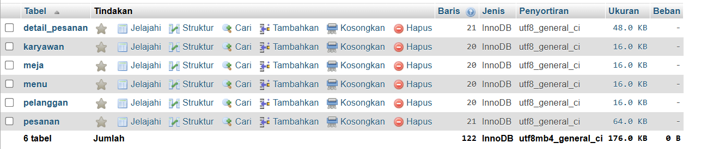

1. **UTF8**



1. **MASUKKAN DATA DUMMY, 20 ROW MINIMAL SETIAP TABELNYA**

| **Keterangan** | **Perintah dan Penampilan** |
| --- | --- |
| Memasukkan 20 data dummy ke tabel pelanggan yang berisi nama, alamat, no telepon, dan email | 1. INSERT INTO pelanggan (nama, alamat, nomor_telepon, email) VALUES   ('Andi Wijaya', 'Jl. Merdeka No. 12', '081234567890'),  ('Budi Santoso', 'Jl. Sudirman No. 45', '081234567891'),  ('Citra Lestari', 'Jl. Gajah Mada No. 22', '081234567892'),  ('Dewi Amalia', 'Jl. Pattimura No. 11', '081234567893'),  ('Eko Susilo', 'Jl. Thamrin No. 20', '081234567894'),  ('Fikri Maulana', 'Jl. Diponegoro No. 30', '081234567895'),  ('Gina Maharani', 'Jl. Kartini No. 25', '081234567896'),  ('Hendra Pratama', 'Jl. Sultan Agung No. 15', '081234567897'),  ('Irma Kusuma', 'Jl. Ahmad Yani No. 50', '081234567898'),  ('Joko Saputra', 'Jl. Jenderal Soedirman No. 78', '081234567899'),  ('Kirana Putri', 'Jl. Cendrawasih No. 13', '081234567900'),  ('Lina Sari', 'Jl. Letjen Suprapto No. 32', '081234567901'),  ('Maya Wulan', 'Jl. Imam Bonjol No. 19', '081234567902'),  ('Nadia Fitri', 'Jl. Gatot Subroto No. 77', '081234567903'),  ('Oka Andika', 'Jl. Sisingamangaraja No. 23', '081234567904'),  ('Putri Ramadhani', 'Jl. Veteran No. 31', '081234567905'),  ('Qori Fadli', 'Jl. Hasanuddin No. 28', '081234567906'),  ('Rama Hermawan', 'Jl. Pemuda No. 18', '081234567907'),  ('Sari Ayu', 'Jl. Raden Saleh No. 17', '081234567908'),  ('Taufik Hidayat', 'Jl. Melati No. 33', '081234567909');  ; |

|  |  |
| --- | --- |
| Memasukkan 20 baris data ke tabel Karyawan, di mana setiap baris mencakup informasi tentang nama, jabatan, nomor handphone, dan gaji. | 1. INSERT INTO karyawan (nama_karyawan, jabatan, nomor_telepon, gaji) VALUES   ('Rina Ambarwati', 'Pelayan'),  ('Agus Wijaya', 'Kasir'),  ('Diana Puspa', 'Pelayan'),  ('Siti Aisyah', 'Barista'),  ('Bambang Sutrisno', 'Koki'),  ('Indra Lesmana', 'Pelayan'),  ('Teguh Prakoso', 'Barista'),  ('Wulan Saputri', 'Pelayan'),  ('Farid Nurcahyo', 'Pelayan'),  ('Yuni Andriani', 'Kasir'),  ('Nugroho Prasetyo', 'Koki'),  ('Lisa Utami', 'Pelayan'),  ('Yanto Susanto', 'Pelayan'),  ('Rika Sari', 'Kasir'),  ('Satria Utama', 'Pelayan'),  ('Putri Damayanti', 'Barista'),  ('Heri Purnomo', 'Pelayan'),  ('Arif Budiman', 'Barista'),  ('Ayu Setiawan', 'Kasir'),  ('Dewi Anggraini', 'Pelayan'); |

| Memasukkan 20 baris data ke tabel Menu | INSERT INTO menu (nama_menu, harga, deskripsi, kategori) VALUES  INSERT INTO menu (nama_menu, harga_menu) VALUES  ('Kopi Hitam', 10000),  ('Teh Manis', 8000),  ('Es Jeruk', 12000),  ('Nasi Goreng', 20000),  ('Mie Goreng', 18000),  ('Roti Bakar', 15000),  ('Soto Ayam', 22000),  ('Bakso', 17000),  ('Mie Ayam', 18000),  ('Es Teh', 5000),  ('Es Kopi Susu', 15000),  ('Kopi Latte', 18000),  ('Cappuccino', 20000),  ('Es Coklat', 12000),  ('Air Mineral', 3000),  ('Nasi Ayam', 25000),  ('Ayam Geprek', 22000),  ('Nasi Uduk', 15000),  ('Kentang Goreng', 12000),  ('Burger', 25000); |
| --- | --- |

| Menambahkan Data Dummy ke table Meja | INSERT INTO meja (nomor_meja, status_meja) VALUES  (1, 'Kosong'),  (2, 'Kosong'),  (3, 'Kosong'),  (4, 'Kosong'),  (5, 'Kosong'),  (6, 'Kosong'),  (7, 'Kosong'),  (8, 'Kosong'),  (9, 'Kosong'),  (10, 'Kosong'),  (11, 'Kosong'),  (12, 'Kosong'),  (13, 'Kosong'),  (14, 'Kosong'),  (15, 'Kosong'),  (16, 'Kosong'),  (17, 'Kosong'),  (18, 'Kosong'),  (19, 'Kosong'),  (20, 'Kosong'); |
| --- | --- |

| Memasukkan 20 baris data ke tabel detail_pesanan, l. | INSERT INTO detail_pesanan (id_pesanan, id_menu, jumlah_pesanan, subtotal) VALUES  (1, 1, 2, 20000),  (1, 3, 1, 12000),  (2, 4, 1, 20000),  (2, 6, 1, 15000),  (3, 5, 2, 36000),  (3, 7, 1, 22000),  (4, 9, 1, 18000),  (4, 2, 2, 16000),  (5, 8, 1, 17000),  (5, 10, 2, 10000),  (6, 11, 1, 15000),  (6, 12, 1, 18000),  (7, 13, 1, 12000),  (7, 14, 2, 24000),  (8, 15, 1, 3000),  (8, 16, 1, 25000),  (9, 17, 1, 22000),  (9, 18, 2, 30000),  (10, 19, 2, 50000),  (10, 20, 1, 25000); |
| --- | --- |

| Memasukkan 20 baris data ke tabel Pesanan. | INSERT INTO pesanan (tanggal_pesanan, total_harga, status_pesanan, id_pelanggan, id_karyawan, id_meja) VALUES  ('2024-12-10', 50000, 'Selesai', 1, 2, 3),  ('2024-12-11', 60000, 'Selesai', 2, 1, 5),  ('2024-12-12', 75000, 'Selesai', 3, 3, 4),  ('2024-12-13', 90000, 'Selesai', 4, 4, 7),  ('2024-12-14', 80000, 'Selesai', 5, 5, 1),  ('2024-12-15', 45000, 'Selesai', 6, 6, 6),  ('2024-12-16', 70000, 'Selesai', 7, 7, 2),  ('2024-12-17', 95000, 'Selesai', 8, 8, 10),  ('2024-12-18', 100000, 'Selesai', 9, 9, 9),  ('2024-12-19', 120000, 'Selesai', 10, 10, 11),  ('2024-12-20', 55000, 'Selesai', 11, 11, 12),  ('2024-12-21', 65000, 'Selesai', 12, 12, 13),  ('2024-12-22', 50000, 'Selesai', 13, 13, 14),  ('2024-12-23', 45000, 'Selesai', 14, 14, 15),  ('2024-12-24', 80000, 'Selesai', 15, 15, 16),  ('2024-12-25', 95000, 'Selesai', 16, 16, 17),  ('2024-12-26', 50000, 'Selesai', 17, 17, 18),  ('2024-12-27', 65000, 'Selesai', 18, 18, 19),  ('2024-12-28', 75000, 'Selesai', 19, 19, 20),  ('2024-12-29', 55000, 'Selesai', 20, 20, 1); |
| --- | --- |

**TRANSACTION**

START TRANSACTION;

INSERT INTO pesanan (tanggal_pesanan, total_harga, status_pesanan, id_pelanggan, id_karyawan, id_meja)

VALUES ('2024-12-30', 90000, 'Selesai', 5, 2, 3);

SET @id_pesanan = LAST_INSERT_ID();

INSERT INTO detail_pesanan (id_pesanan, id_menu, jumlah_pesanan, subtotal)

VALUES (@id_pesanan, 4, 2, 40000),

(@id_pesanan, 7, 1, 50000);

UPDATE meja SET status_meja = 'Terisi' WHERE id_meja = 3;

COMMIT;

Laporan Dan Transaksi

SELECT

p.id_pesanan AS 'ID Pesanan',

p.tanggal_pesanan AS 'Tanggal Pesanan',

pl.nama_pelanggan AS 'Nama Pelanggan',

k.nama_karyawan AS 'Nama Karyawan',

m.nama_menu AS 'Nama Menu',

dp.jumlah_pesanan AS 'Jumlah Pesanan',

dp.subtotal AS 'Subtotal',

p.total_harga AS 'Total Harga',

me.nomor_meja AS 'Nomor Meja',

me.status_meja AS 'Status Meja',

p.status_pesanan AS 'Status Pesanan'

FROM

pesanan p

JOIN

pelanggan pl ON p.id_pelanggan = pl.id_pelanggan

JOIN

karyawan k ON p.id_karyawan = k.id_karyawan

JOIN

detail_pesanan dp ON p.id_pesanan = dp.id_pesanan

JOIN

menu m ON dp.id_menu = m.id_menu

JOIN

meja me ON p.id_meja = me.id_meja

ORDER BY

p.tanggal_pesanan DESC;

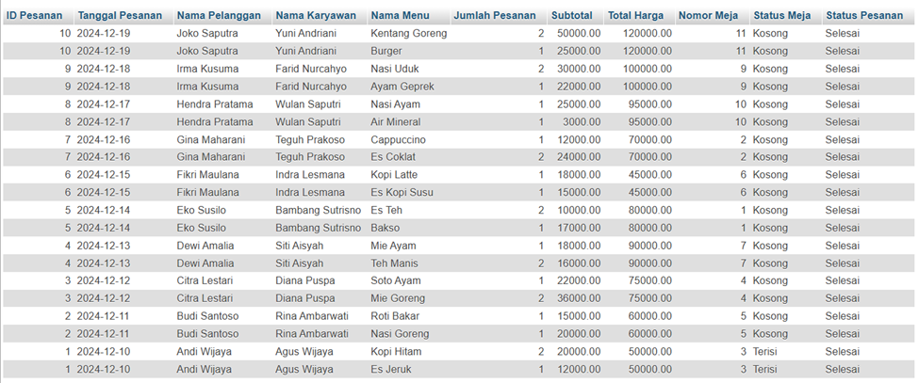

**Skenario apabila ada kesalahan maka seluruh transaksi batal**

**Pembatalan Pesanan**

-- Mulai transaksi

START TRANSACTION;

1. Hapus detail pesanan dari tabel `detail_pesanan`

DELETE FROM detail_pesanan WHERE id_pesanan = 5;

2. Hapus pesanan dari tabel `pesanan`

DELETE FROM pesanan WHERE id_pesanan = 5;

3. Update status meja menjadi 'Kosong'

UPDATE meja SET status_meja = 'Kosong' WHERE id_meja = 3;

Simpan perubahan jika semua operasi berhasil

COMMIT;

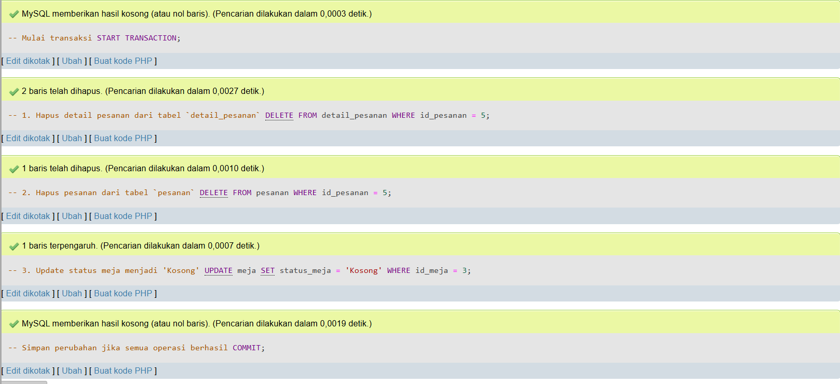

Update Data Pelanggan

UPDATE pelanggan

SET nama_pelanggan = 'Budi Raharjo', no_telepon = '081298765432'

WHERE id_pelanggan = 1;



Delete Detail Pesanan

DELETE FROM detail_pesanan

WHERE id_detail_pesanan = 1;



**LINK GITHUB:**

https://github.com/rezaginting2312/Tubes_Basdat

Dokumentasi Kerja Kelompok:

